Job Vacancy
Market Place Books
Promoting Christ – Providing Resources – Supporting The Church
26 Market Place, Kendal, Cumbria LA9 4TN Tel:01539 724532
www.marketplacebooks.org.uk manager@marketplacebooks.org
Enthusiastic, capable Person
Required for 8-12 hours a week to work in the shop and support the Manager
at long established Christian bookshop in Kendal
Salary : £10 an hour

Application pack from Market Place Books
(or on our website or via email)
Start date: October 18th 2022
Closing date for applications:
Monday September 19th 2022

Job Vacancy
Market Place Books
Promoting Christ – Providing Resources – Supporting The Church
26 Market Place, Kendal, Cumbria LA9 4TN Tel: 01539 724532
www.marketplacebooks.org.uk manager@marketplacebooks.org
Enthusiastic, capable Person
Required for 8-12 hours a week to work in the shop and support the Manager
at long established Christian bookshop in Kendal
Salary : £10 an hour
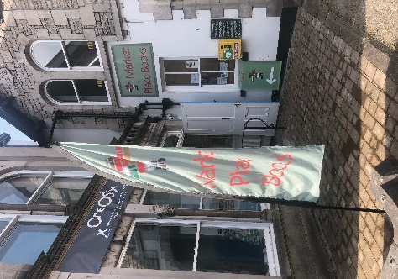
Application pack from Market Place Books
(or on our website or via email)
Start date: October 18th 2022
Closing date for applications:
Monday September 19th 2022
Provisional interview date- Monday Oct 3rd
details on receipt of application

Setails on receipt of application
Provisional interview date – Monday Oct 3rd
details on receipt of application
Kendal & District Christian Literature Society: Charity No 505981
Kendal & District Christian Literature Society : Charity No: 505981

